**Passport and Visa Consultancy**

A project submitted to

**UKA TARSADIA UNIVERSITY**

**Bachelor of Science**

**in**

**Information Technology**

By

**Yagnik Trivedi**

201506100110052

**Gautam Purohit**

201506100110137

Guided By

**Mr. Manish Vala**



**Babu Madhav Institute of Information Technology**

### Uka Tarsadia University

### Bardoli - 394350

**October - 2017**

**CERTIFICATE**



This is to certify that **Yagnik Trivedi (201506100110052), Gautam Purohit (201506100110137)** has submitted projectentitled **Passport and Visa Consultancy** as the partial fulfilment for the award of the degree of Bachelor of Science in Information Technology for 5 Years Integrated M.Sc.(IT) in 2017 – 2018.

**Date:**

**Place:**

|  |  |
| --- | --- |
| **Mrs. Manish Vala** | **Mr. Jitendra Nasriwala** |
| Guide | Programme Coordinator, |
|  |  |
|  | Babu Madhav Institute of Information Technology |

**External Examiner**

**Babu Madhav Institute of Information Technology,**

**Uka Tarsadia University,**

**Bardoli - 394350**

**Acknowledgement**

Nothing concrete can be achieved without an optimal combination of inspiration and perspiration. No work can be accomplished without taking the guidance from Mr. Manish Vala (Faculty). It is only the views and advice from ingenious intellectual that help in the transformation of a product into a quality product. I gratefully thanks to Mr Jitendra Nasriwala who has given us the opportunity and also our friends, parents, teachers and others who supported us throughout the project.

|  |  |  |  |
| --- | --- | --- | --- |
| **No.** |  | **Description** | **Page No.** |
| 1. |  | List of Tables, Figures, Schemes | 5 |
| 2 |  | Abstract / Introduction | 6 |
| 3. |  | Purpose and Scope | 7 |
| 4. |  | Hardware and Software Requirements | 8 |
| 5. |  | System Analysis | 9 |
|  | 5.1  5.2  5.3  5.4  5.5  5.6  5.7  5.8 | Identification of Needs  Functional Requirements  Non – Functional Requirements  Modules  User Characteristics  Use Case Description Form  Use Case Diagrams  Activity Diagrams | 10  11  12  13  14  15  22  23 |
| 6. |  | Data Dictionary (Field Name, Datatype, Size, Constraints, Description) | 27 |
| 7. |  | User Interface Design (snapshots) | 36 |
| 8. |  | Test Cases and Snapshots of validations | 50 |
| 9. |  | Technical Details of new features, plug-inn tools | 55 |
| 10. |  | Future Enhancement | 56 |
| 11. |  | Conclusion | 57 |
| 12. |  | Learning / Experience During Project Work | 58 |
| 13. |  | References | 59 |
| 14 |  | Bibliography | 60 |

**List of Tables and Figures:**

**Figures:**

Use Case

Activity

Database Schema

**Abstract / Introduction:**

As International standard are necessary for an effective global passport and visa consultancy.

The system provides the customers to apply for passport and visa and get guidance of collecting the documents for passport and visa through agents.

**Purpose:**

To provide facility for the application of passport and visa.

To provide information to the customer for applying for a passport/visa.

**Scope:**

The system allows customer to apply for visa and passport through agents.

The system does not provide any information about travelling, trip plans or countries.

The system is limited to the confirmation of passport and visa.

The system does not include flight bookings or view any information about flights.

**Hardware Requirements:**

A PC or Laptop or Mobile device to use the website

**Software Requirements:**

Any web browser.

Internet Connection

**System Analysis:**

**Identification of Needs:**

Currently, if one wants passport/visa he/she has to go at an passport/visa consultant office and has to submit the hardcopy of the documents.

The system eliminates this and allows them to apply for passport/visa without hardcopy and contact to the agent directly from the website.

The customer can get all information and guidance about applying for passport and visa directly from the website.

**Functional Requirements:**

The system should have provision for the Administrator to register Agent and add/view the agent information.

The system should have provision for the Agent to add/view information about the customer and provide passport/visa service.

The system should provide information about the procedures and documents required for applying for passport/visa.

The Administrator and Agent should be able to see the reports of passport/visa.

The Administrator should be able to make payment of the Agent.

The Agent should be able to make payment of the Customer.

**Non-Functional Requirements:**

24*7 internet connectivity should be provided for the well-functioning of the system.

The users of the system should provide User-Id and password along with the well-defined access privileges.

The information provided about passport/visa are true, verified, clear and definite.

Storing confidential information in encrypted form.

The person who is details of any user of the system is not duplicated.

.

**Modules:**

Login

Visitor

Admin

Agent

Provide Passport Services

Provide Visa Services

Payment

**User Characteristics:**

Admin Registers Agent,

Admin can see all Agents, Passports application, visa application make payment of agent, remove agent.

Agent applies for Passport, Visa, update passport document verification date, Police Inquiry Date, and Visa Interview date.

Agent can make payment of customer.

Agent can see his/her customers, passport applications, visa applications.

Admin and agent can change their passwords.

**Use Case Description:**

**Register Agent:**

|  |
| --- |
| **Introduction**: This use case document depicts the steps which should be followed to register an agent. |
| **Actors :**  Admin |
| **Precondition :** Assume that the Admin already logged in. |
| **Post condition:** The agent will be registered. |
| **Event Flow:**   1. Admin open form to register agent. 2. Admin enters all information required. 3. Admin submits the form. |
| **Alternative Flow:**   1. Internet connection lost. 2. Admin exits. 3. Any other technical problem. |
| **Special Requirement:**  None |
| **Associated Use Case:**  Login |

**Apply Passport:**

|  |
| --- |
| **Introduction**: This use case document depicts the steps which should be followed to apply for a passport. |
| **Actors :**  Agent |
| **Precondition :** Assume that the Agent is already logged in. |
| **Post condition:** The Passport will be applied. |
| **Event Flow:**   1. Agent opens form to apply for passport. 2. Agent enter personal details applicant. 3. Agent enter passport details and payment details. 4. Agent submits the form. |
| **Alternative Flow:**   1. Internet connection lost. 2. Agent exits. 3. Any other technical problem. |
| **Special Requirement:**  None |
| **Associated Use Case:**  Login |

**Apply Visa:**

|  |
| --- |
| **Introduction**: This use case document depicts the steps which should be followed to Apply for a visa. |
| **Actors :**  Agent |
| **Precondition :** Assume that the Agent is already logged in. |
| **Post condition:** The visa will be applied. |
| **Event Flow:**   1. Agent opens form to apply for visa. 2. Agent enter personal details of applicant. 3. Agent enter visa details and payment details. 4. Agent submits the form |
| **Alternative Flow:**   1. Internet connection lost. 2. Agent exits. 3. Any other technical problem. |
| **Special Requirement:**  None |
| **Associated Use Case:**  Login |

**Update passport dates:**

|  |
| --- |
| **Introduction**: This use case document depicts the steps which should be followed to update the passport document verification and police inquiry date. |
| **Actors :**  Agent |
| **Precondition :** Assume that the Agent is already logged in. |
| **Post condition:** The dates of passport will be updated. |
| **Event Flow:**   1. Agent opens form to update dates for passport. 2. Agent select passport application no. 3. Agent select the document verification date and police inquiry date. 4. Agent submits the form. |
| **Alternative Flow:**   1. Internet connection lost. 2. Agent exits. 3. Any other technical problem |
| **Special Requirement:**  None |
| **Associated Use Case:**  Login |

**Update visa interview date:**

|  |
| --- |
| **Introduction**: This use case document depicts the steps which should be followed to update the visa interview date. |
| **Actors :**  Agent |
| **Precondition :** Assume that the Agent is already logged in. |
| **Post condition:** The date of visa interview will be updated will be updated. |
| **Event Flow:**   1. Agent opens form to update dates for visa. 2. Agent select visa application no. 3. Agent select the date of interview. 4. Agent submits the form. |
| **Alternative Flow:**   1. Internet connection lost. 2. Agent exits. 3. Any other technical problem |
| **Special Requirement:**  None |
| **Associated Use Case:**  Login |

**Agent Payment:**

|  |
| --- |
| **Introduction**: This use case document depicts the steps which should be followed to make payment of agent by admin. |
| **Actors :**  Admin |
| **Precondition :** Assume that the Admin is already logged in. |
| **Post condition:** The remaining amount of the agent will be updated. |
| **Event Flow:**   1. Admin opens form to make payment. 2. Agent select agent id. 3. Admin submits the form. |
| **Alternative Flow:**   1. Internet connection lost. 2. Admin exits. 3. Any other technical problem |
| **Special Requirement:**  None |
| **Associated Use Case:**  Login |

**Customer payment:**

|  |
| --- |
| **Introduction**: This use case document depicts the steps which should be followed to make payment of agent by admin. |
| **Actors :**  Agent |
| **Precondition :** Assume that the agent is already logged in. |
| **Post condition:** The remaining amount of the customer will be updated. |
| **Event Flow:**   1. Admin opens form to make payment. 2. Agent select agent id. 3. Agent submits the form. |
| **Alternative Flow:**   1. Internet connection lost. 2. Agent exits. 3. Any other technical problem |
| **Special Requirement:**  None |
| **Associated Use Case:**  Login |

**Use Case Diagram:**

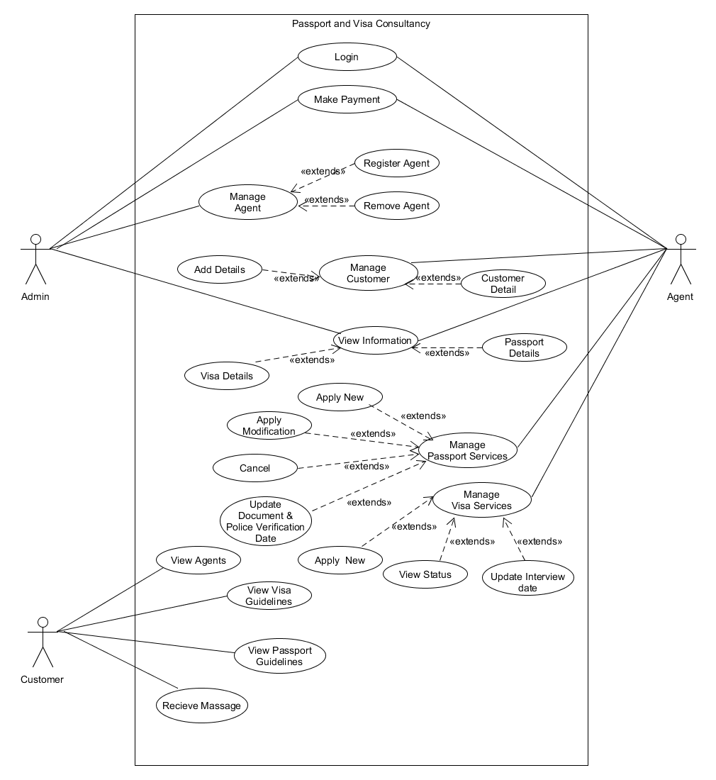

**Activity Diagrams:**

***Login:***

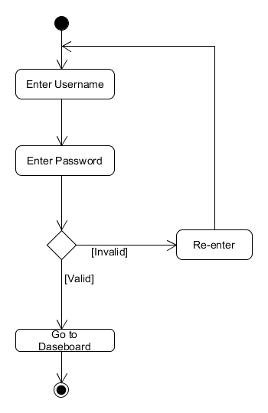

***Customer Payment:***

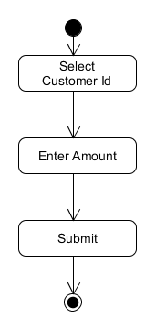

***Agent Payment:***

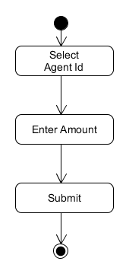

***Manage Passport:***

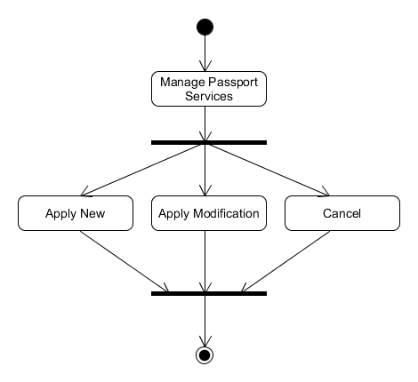

***Manage Visa:***

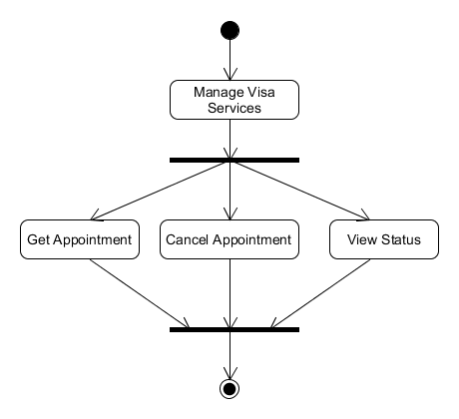

***View Details:***

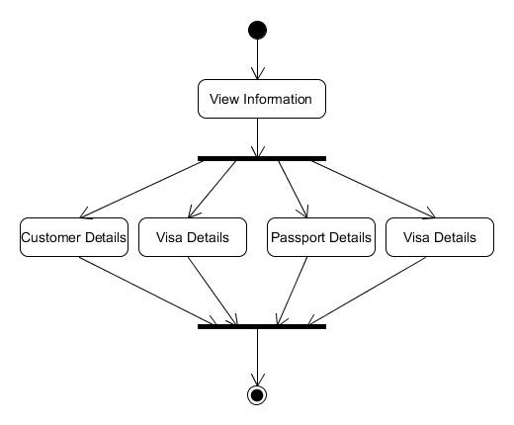

**Data Dictionary:**

**Tbl_Agent_Details:**

|  |  |  |  |  |
| --- | --- | --- | --- | --- |
| **Field** | **Type** | **Size** | **Constraint** | **Description** |
| **Person_id** | **Int** | **-** | **Foreign key** | **Reference table Tbl_Person_Details** |
| **Login_Id** | **Int** | **-** | **Foreign key** | **Reference table Tbl_Login** |
| **Remaining_Amount** | **money** | **-** | **Not null** | **Remaining amount of agent** |

**Tbl_Login:**

|  |  |  |  |  |
| --- | --- | --- | --- | --- |
| **Field** | **Type** | **Size** | **Constraint** | **Description** |
| **Login_Id** | **Int** | **-** | **Primary Key** | **Login id of the user** |
| **Username** | **Varchar()** | **40** | **Unique** | **Username of the user** |
| **Password** | **Varchar()** | **40** | **Not null** | **Password of the user** |
| **User_type** | **Varchar()** | **5** | **Not null** | **Type of user Admin/Agent** |

**Tbl_Customer_Details:**

|  |  |  |  |  |
| --- | --- | --- | --- | --- |
| **Field** | **Type** | **Size** | **Constraint** | **Description** |
| **Customer_Id** | **Int** | **-** | **Primary key** | **Unique id of Customer** |
| **Person_id** | **Int** | **-** | **Foreign key** | **Reference table tbl_Person_Detail** |
| **Remaining_Amount** | **money** | **-** | **Not null** | **Remaining amount of customer** |
| **Joining_Date_Time** | **date** | **-** | **Not null** | **Time at which referral is registered** |

**Tbl_Personal_Details:**

|  |  |  |  |  |
| --- | --- | --- | --- | --- |
| **Field** | **Type** | **Size** | **Constraint** | **Description** |
| **Person_Id** | **Int** | **-** | **Primary Key** | **Unique id of each person** |
| **First Name** | **Varchar()** | **40** | **Not null** | **First name of Person** |
| **Middle Name** | **Varchar()** | **40** | **Not null** | **Middle name of Person** |
| **Last_Name** | **Varchar()** | **40** | **Not null** | **Last name of Person** |
| **Date_Of_Birth** | **Date** | **-** | **Not null** | **Birthdate** |
| **Gender** | **Char()** | **1** | **Not null** | **Gender of person** |
| **Address** | **Varchar()** | **150** | **Not null** | **Address (street)** |
| **Pin_Code** | **Char()** | **6** | **Foreign Key** | **Pin code of city Reference Table: Tbl_Pin_Codes** |
| **Adhar_Card_No** | **Char()** | **12** | **Not null** | **For identity** |
| **Contact_No** | **Varchar()** | **13** | **Not null** | **For contact** |
| **Email_id** | **Varchar()** | **40** | **Not null** | **Email id of Person** |

**Tbl_Passport_Details:**

|  |  |  |  |  |
| --- | --- | --- | --- | --- |
| **Field** | **Type** | **Size** | **Constraint** | **Description** |
| **Passport_Serial_No** | **Int** | **-** | **Primary Key** | **Unique id of each Passport applicant** |
| **Customer_Id** | **Int** | **-** | **Foreign Key** | **Reference Table: Tbl_Customer_Details** |
| **Passport_Service** | **Varchar()** | **15** | **Not null** | **Service : new/update/cancel** |
| **Person_Id** | **Int** | **-** | **Foreign Key** | **Reference Table: Tbl_Personal_Details** |
| **Status** | **Varchar()** | **15** | **Not null** | **Confirmed/pending** |
| **Agent_Id** | **Int** | **-** | **Foreign Key** | **Reference Table:**  **Tbl_Login** |
| **Amount** | **Int** | **-** | **Not null** | **Amount to be paid for passport** |
| **Img_path_Leaving_Certificate** | **Varchar()** | **200** | **Not null** | **Image of Leaving certificate of applicant** |
| **Img_path_Birth_Certificate** | **Varchar()** | **200** | **Not null** | **Image of Birth certificate of applicant** |
| **Img_path_Passport_Picture** | **Varchar()** | **200** | **Not null** | **Passport Size of applicant** |
| **Img_path_Adhar_Card** | **Varchar()** | **200** | **Not null** | **Image of adhar card of applicant** |
| **Primary_Document** | **Varchar()** | **25** | **Not null** | **The document which is considered for confirm information of applicant** |
| **Date_Of_Applying** | **date** | **-** | **Not null** | **The date and time at which application is done.** |
| **Document_Verification_Date** | **Date** | **-** | **Allow null** | **The date for the applicant for document verification** |
| **Police_Inquiry_Date** | **Date** | **-** | **Allow null** | **The date for the applicant for police inquiry** |

**Tbl_Visa_Details:**

|  |  |  |  |  |  |
| --- | --- | --- | --- | --- | --- |
| **Field** | **Type** | **Size** | **Constraint** | | **Description** |
| **Visa_Serial_No** | **Int** | **-** | **Primary Key** | **Unique id of each Visa applicant** | |
| **Customer_Id** | **Int** | **-** | **Foreign Key** | **Reference Table: Tbl_Customer_Details** | |
| **Visa_Service** | **Varchar()** | **15** | **Not null** | **Service : get appointment/cancel appointment** | |
| **Person_Id** | **Int** | **-** | **Foreign Key** | **Reference Table: Tbl_Personal_Details** | |
| **Status** | **Varchar()** | **50** | **Not null** | **Confirmed/pending** | |
| **Agent_Id** | **Int** | **-** | **Foreign Key** | **Reference Table:**  **Tbl_Login** | |
| **Amount** | **Int** | **-** | **Not null** | **Amount to be paid for passport** | |
| **Country** | **Varchar()** | **30** | **Not null** | **Country for which applying** | |
| **Passport_No** | **Varchar()** | **20** | **Not null** | **Passport no of visa applicant** | |
| **Img_path_Passport_Picture_Side_1** | **Varchar()** | **200** | **Not null** | **Passport copy front page** | |
| **Img_path_Passport_Picture_Side_2** | **Varchar()** | **200** | **Not null** | **Passport copy last page** | |
| **Date_of_appling** | **Date and Time** | **-** | **Not null** | **The date and time at which application is done.** | |
| **Visa_Interview_Date** | **Date** | **-** | **Allow null** | **Date for interview of Visa** | |

**Tbl_Customer_Agent_Relation**

|  |  |  |  |  |
| --- | --- | --- | --- | --- |
| **Field** | **Type** | **Size** | **Constraint** | **Description** |
| **Customer_Id** | **Int** | **-** | **Foreign Key** | **Reference Table: Tbl_Customer_Details** |
| **Agent_Id** | **Int** | **-** | **Foreign Key** | **Reference Table: Tbl_Login_Details** |

**Tbl_Customer_Agent_Payment:**

|  |  |  |  |  |
| --- | --- | --- | --- | --- |
| **Field** | **Type** | **Size** | **Constraint** | **Description** |
| **Payment_Id** | **Int** | **-** | **Primary Key** | **Unique id of each payment done** |
| **Customer_Id** | **Int** | **-** | **Foreign Key** | **Reference Table: Tbl_Customer_Details** |
| **Agent_Id** | **Int** | **-** | **Foreign Key** | **Reference Table : Tbl_Agent_Details** |
| **Paid_Amount** | **Int** | **-** | **Not null** | **Amount paid on current day** |
| **Payment_Date_and_Time** | **date** | **-** | **Not null** | **Current Date and Time** |

**Tbl_Agent_Admin_Payment:**

|  |  |  |  |  |
| --- | --- | --- | --- | --- |
| **Field** | **Type** | **Size** | **Constraint** | **Description** |
| **Payment_Id** | **Int** | **-** | **Primary Key** | **Unique id of each payment done** |
| **Agent_Id** | **Int** | **-** | **Foreign Key** | **Reference Table:**  **Tbl_Agent_Details** |
| **Paid_Amount** | **money** | **-** | **Not null** | **Amount paid on same day** |
| **Payment_Date_Time** | **date** | **-** | **Not null** | **Current Date and Time** |

**Tbl_Pin_Codes:**

|  |  |  |  |  |
| --- | --- | --- | --- | --- |
| **Field** | **Type** | **Size** | **Constraint** | **Description** |
| **Pin_codes** | **Char()** | **6** | **Primary Key** | **Each Unique pin code** |
| **City** | **Varchar()** | **50** | **Not null** | **Name of City** |
| **District** | **Varchar()** | **50** | **Not null** | **Name of Districts** |
| **States** | **Varchar()** | **50** | **Not null** | **Name of States** |

**Snapshots:**

**Payment For Admin**

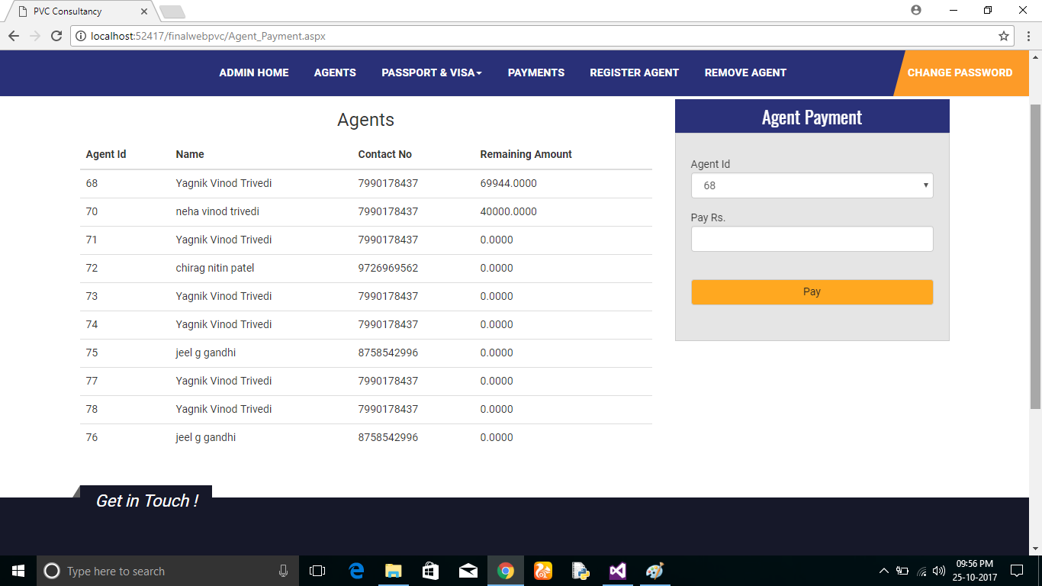

**View Visa To Admin**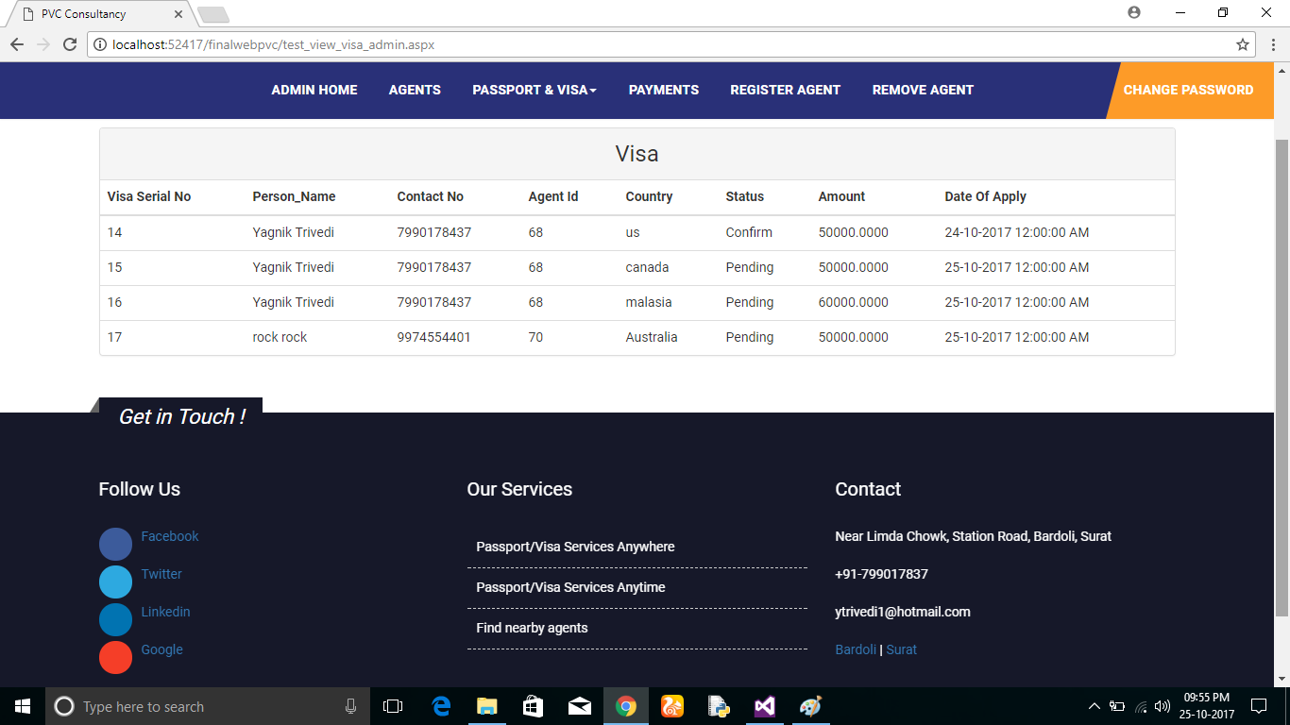

**View Passport To Admin**

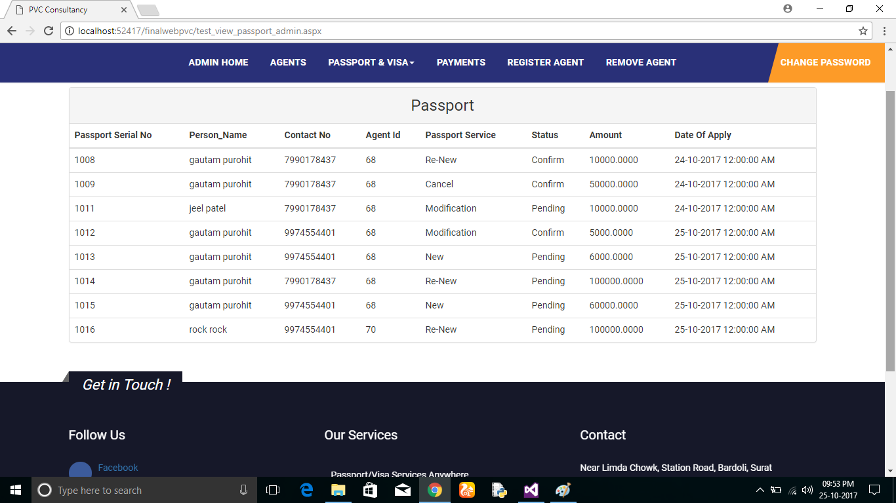

**View Agent To Admin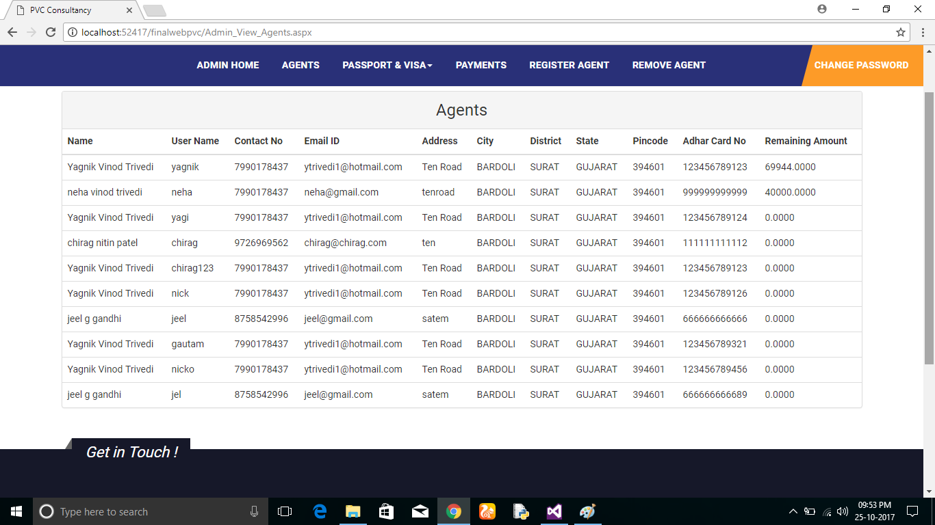Admin Home Page**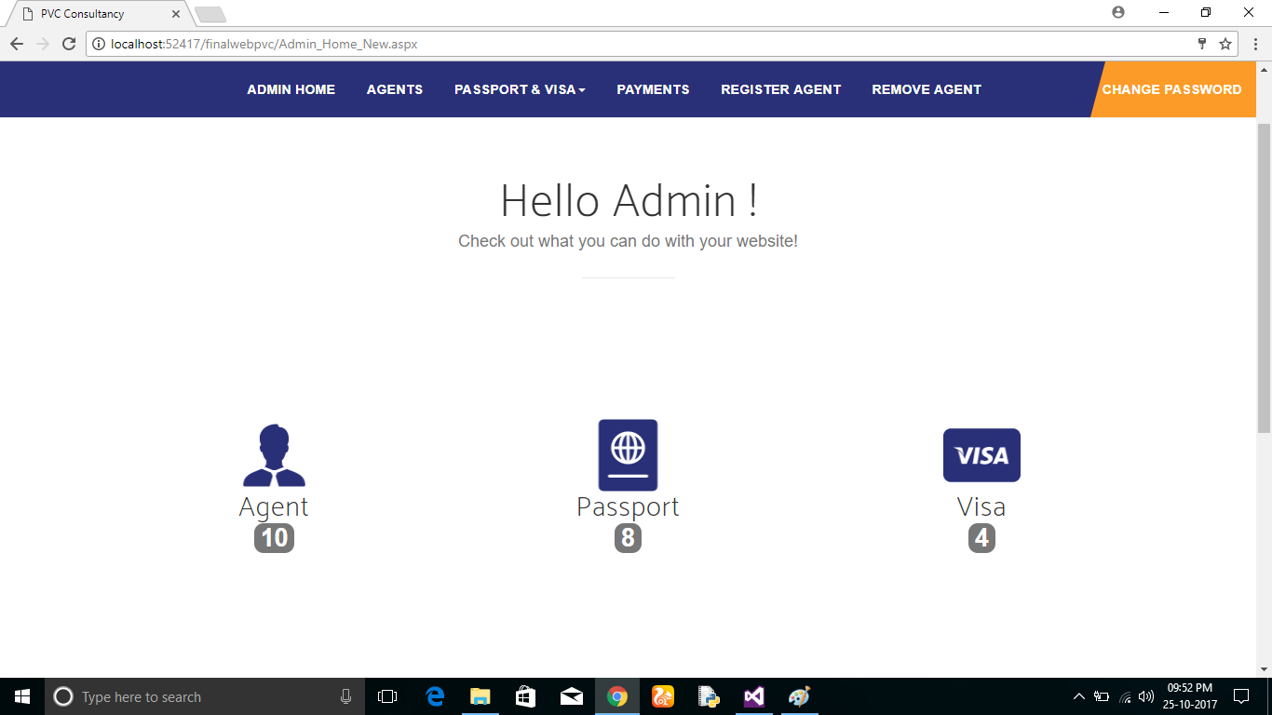

**Change Password Of Admin**

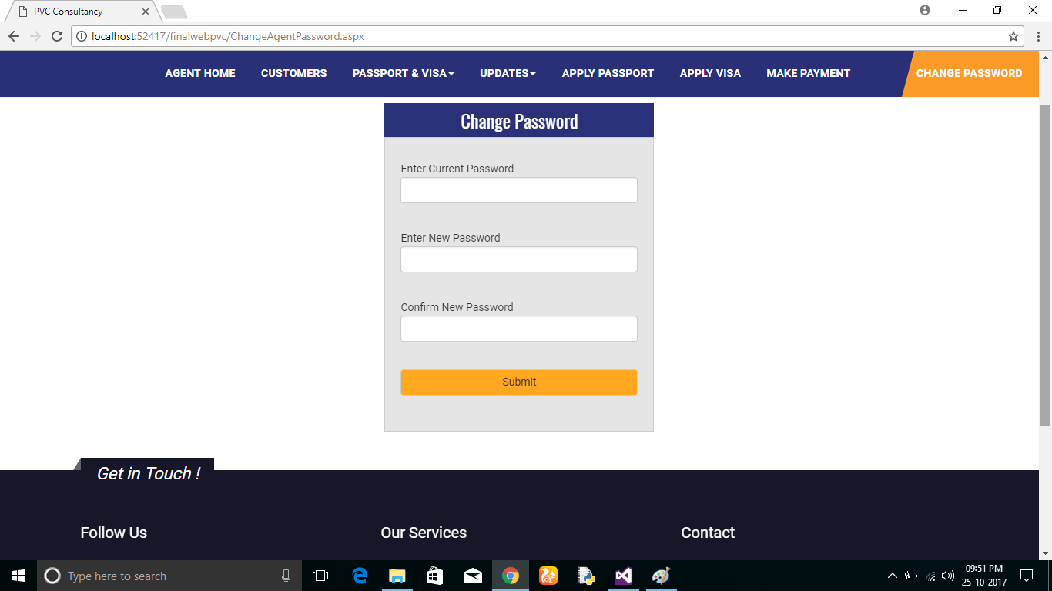

**Remove Agent**

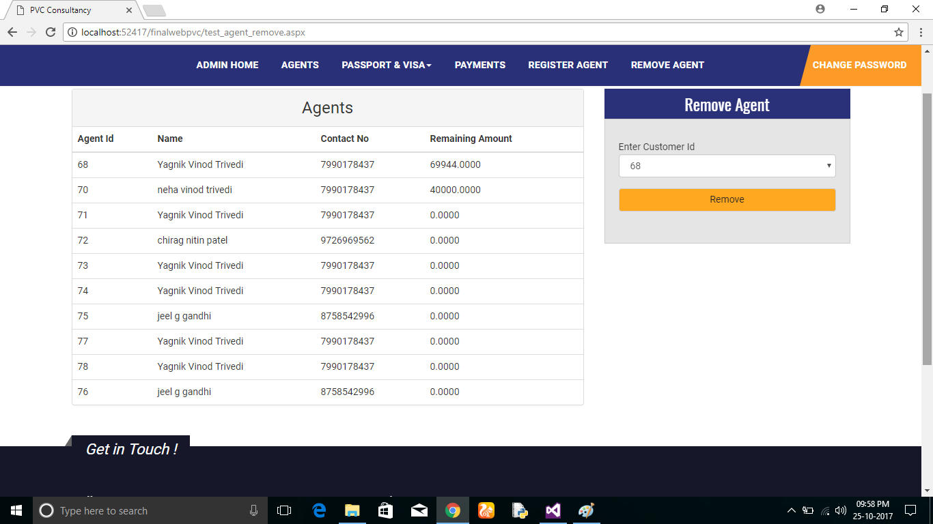

**Payment For Agent**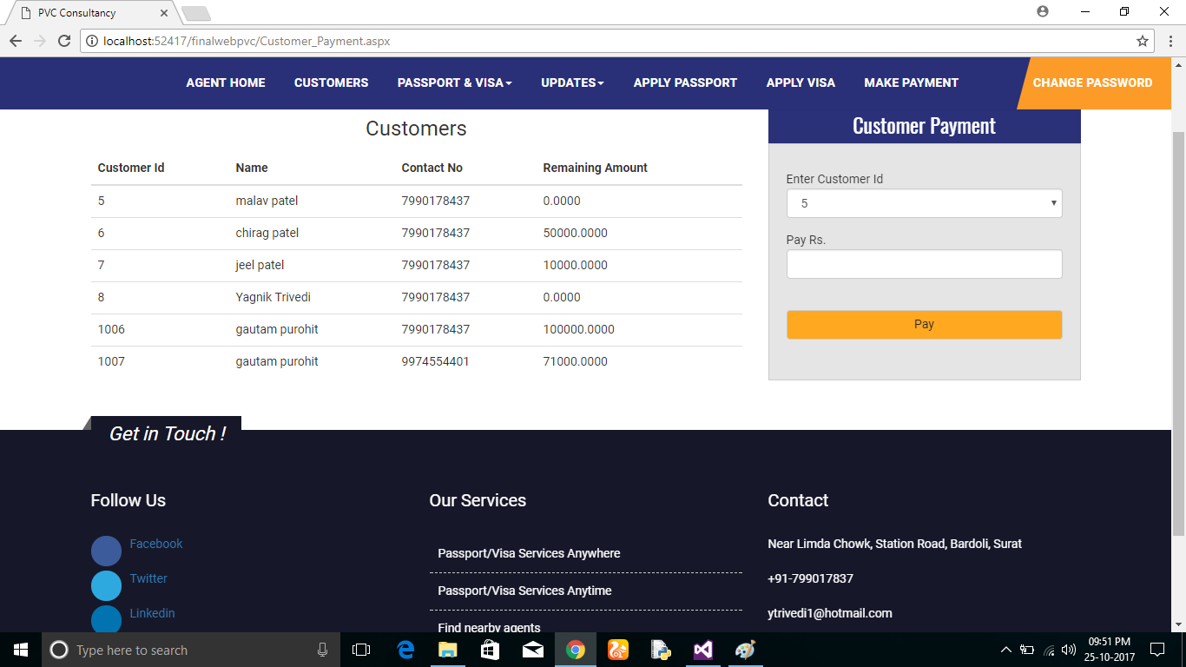

**Visa Details**

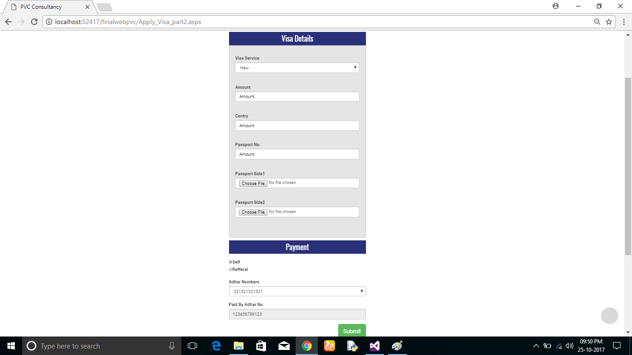

**Passport Detail**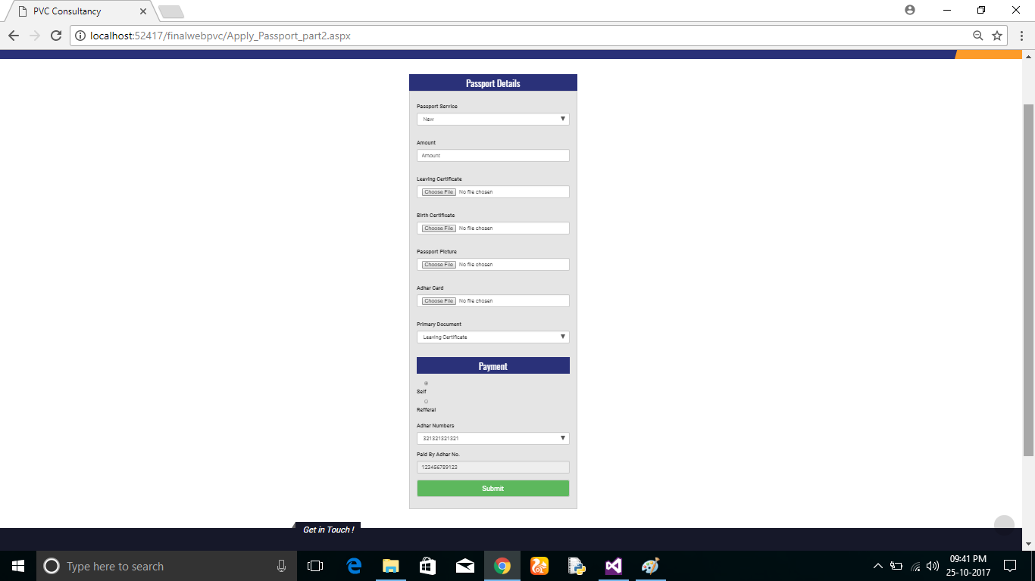

**Customer Details**

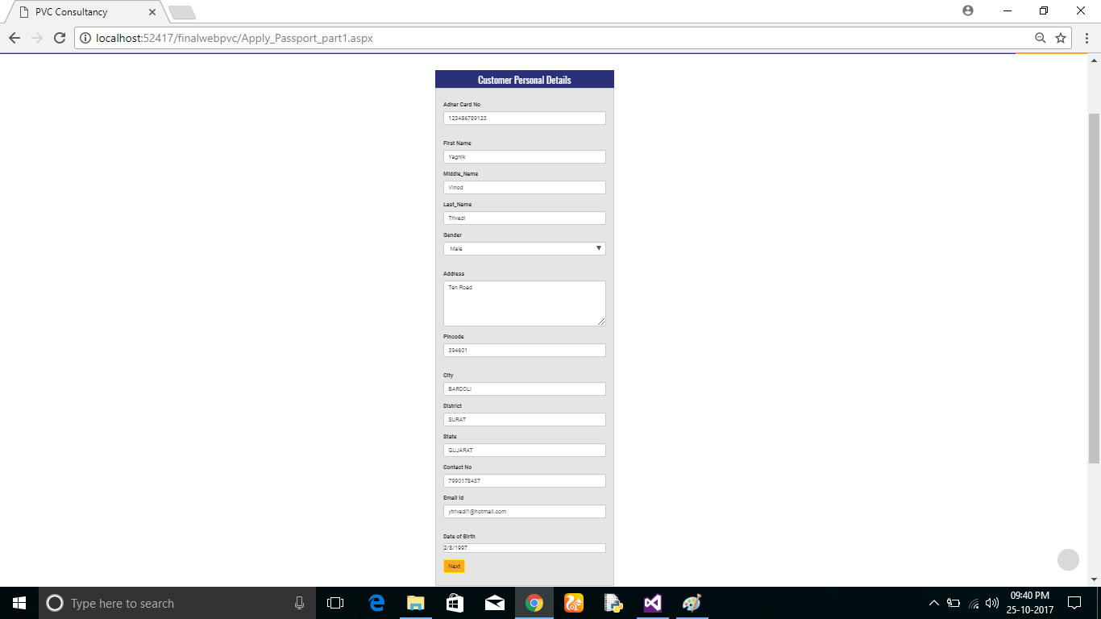

**Update Visa Interview Date**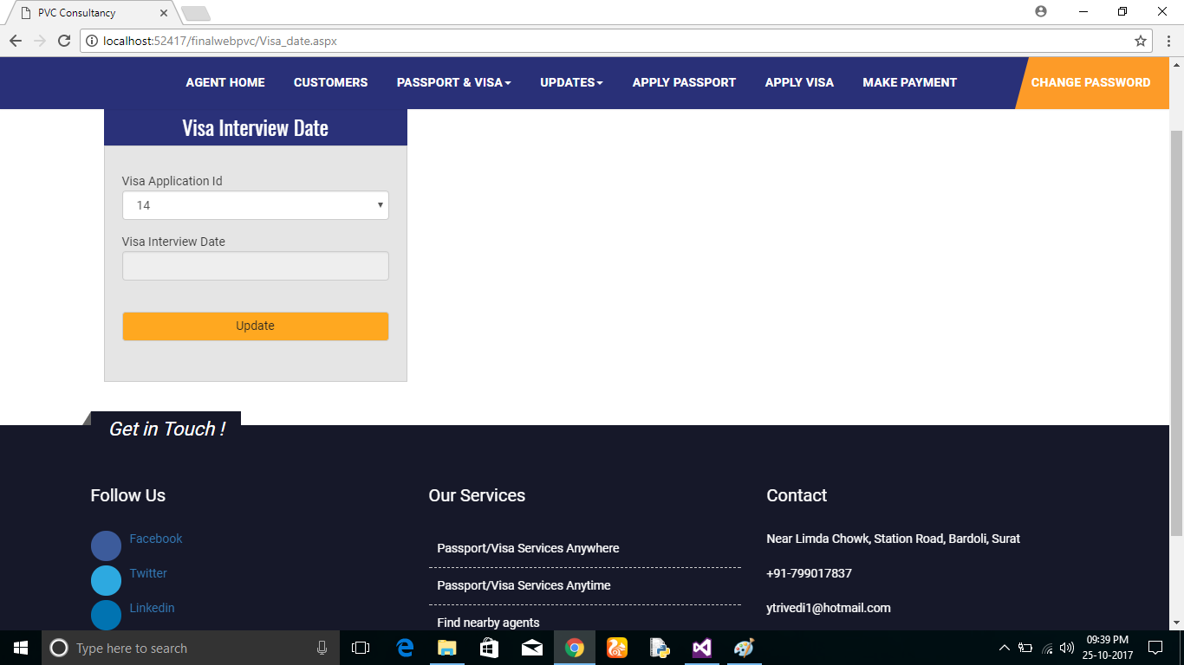

**Update Passport Document & Police Verification Date**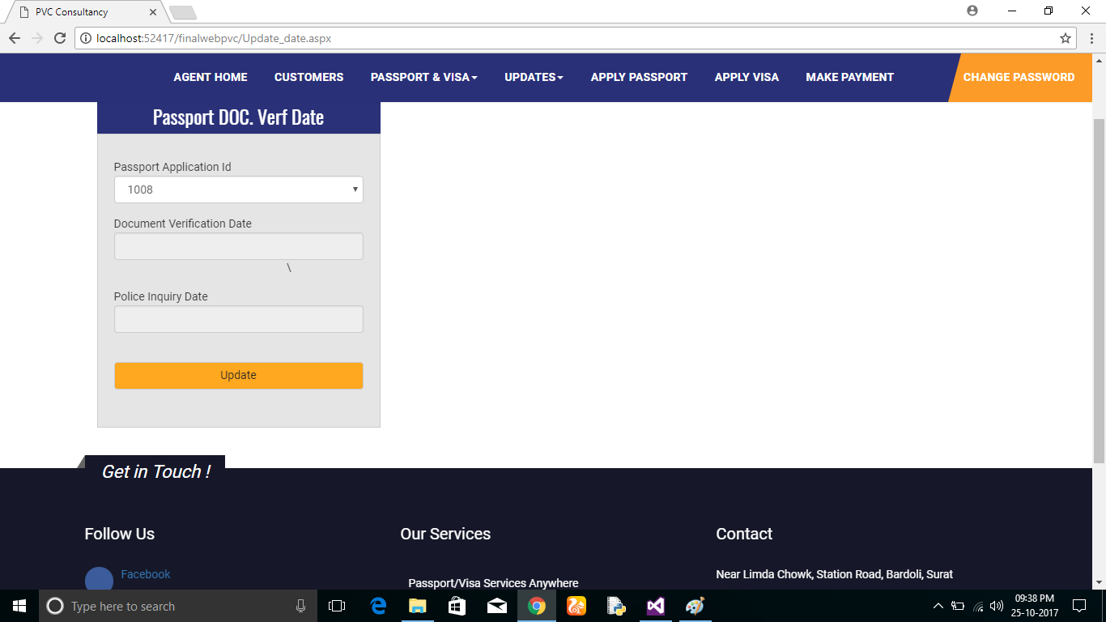

**View Visa Of Agent**

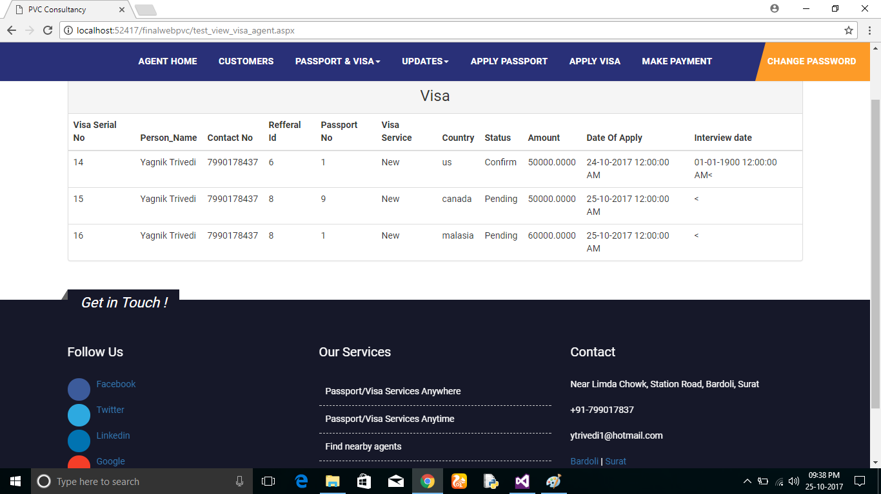

**View Passport Of Agent**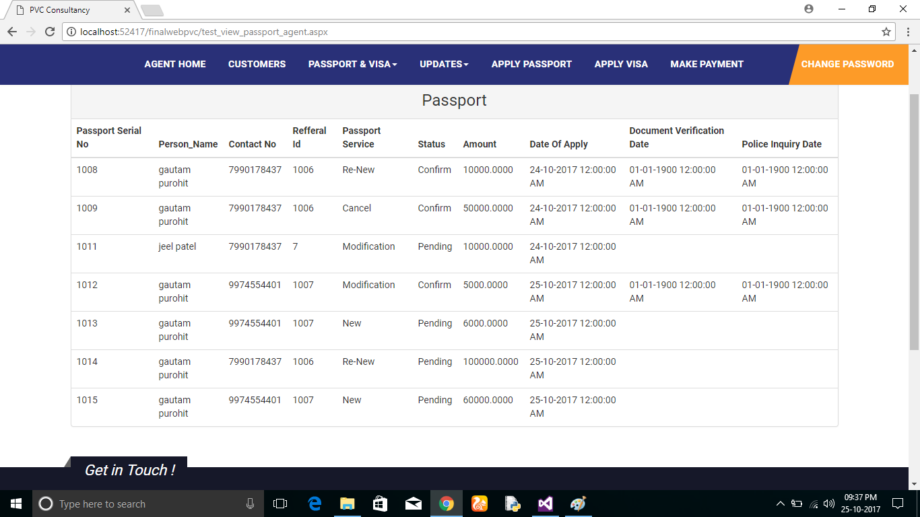

**View Customer Of Agent It Self**

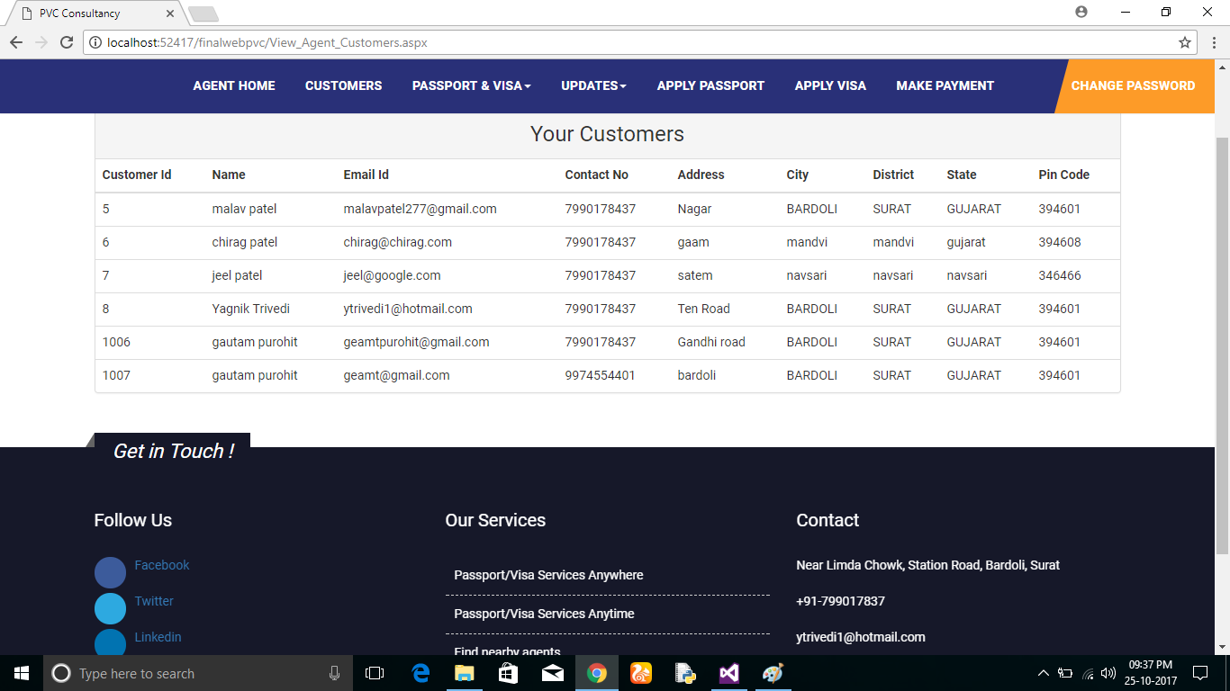

**Home Page of Agent It Self**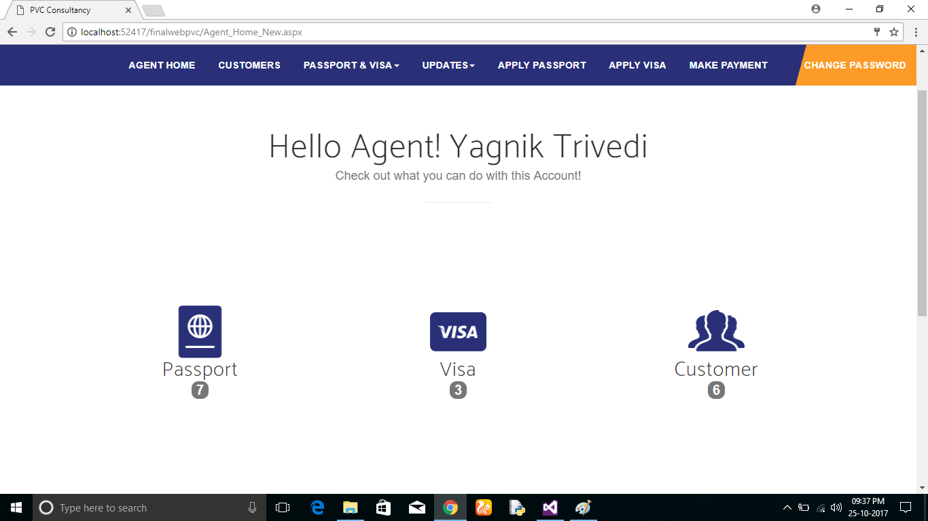

**Login**

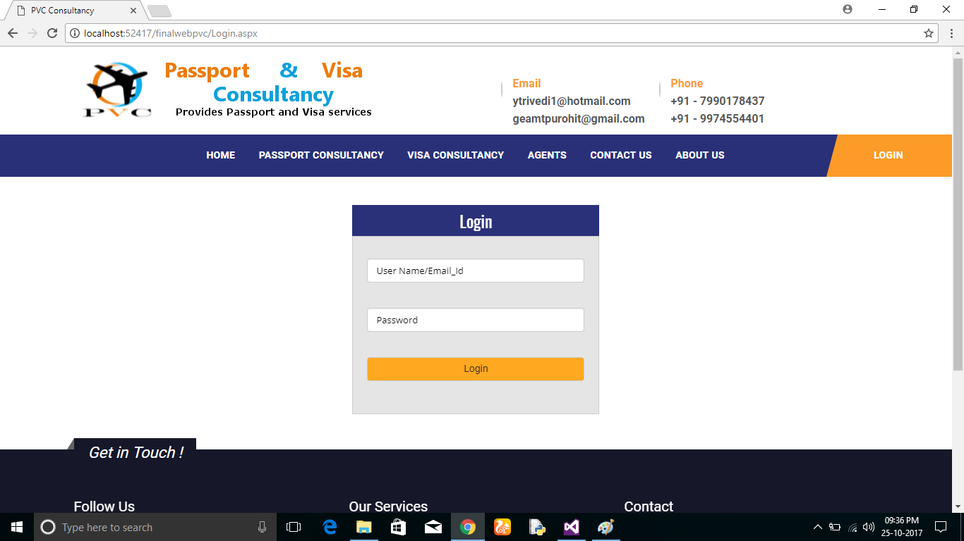

**About Us** 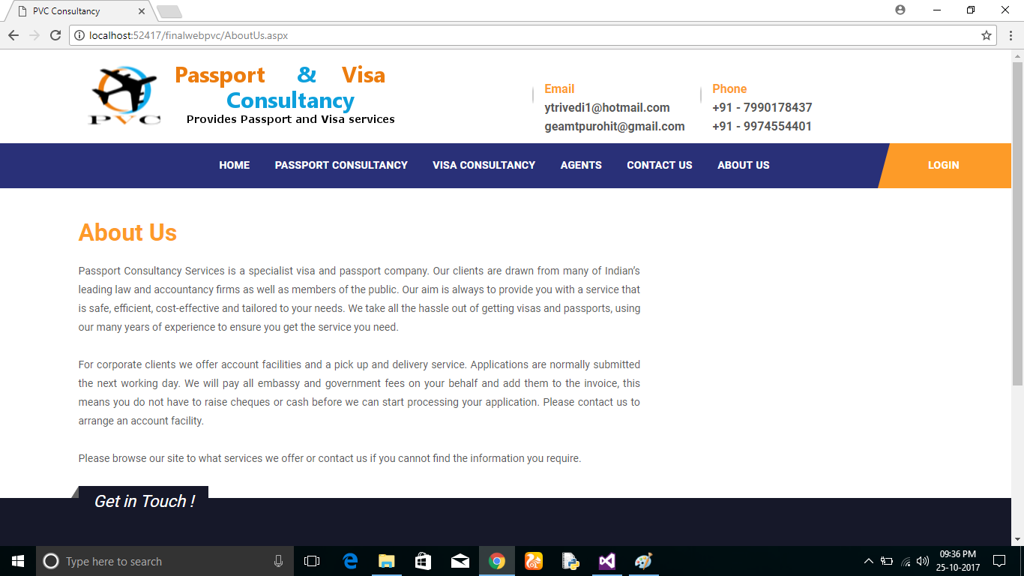

**Contact Us**

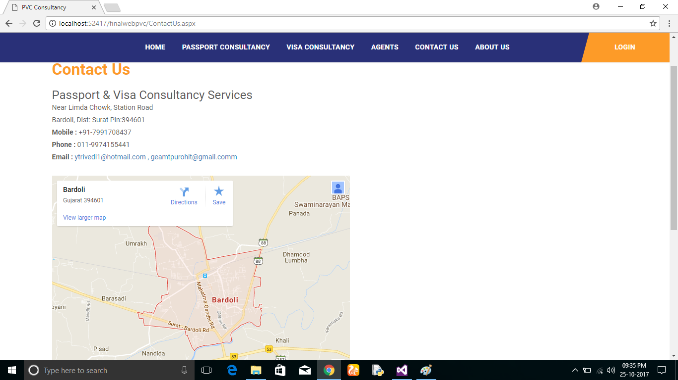

**View All Agent**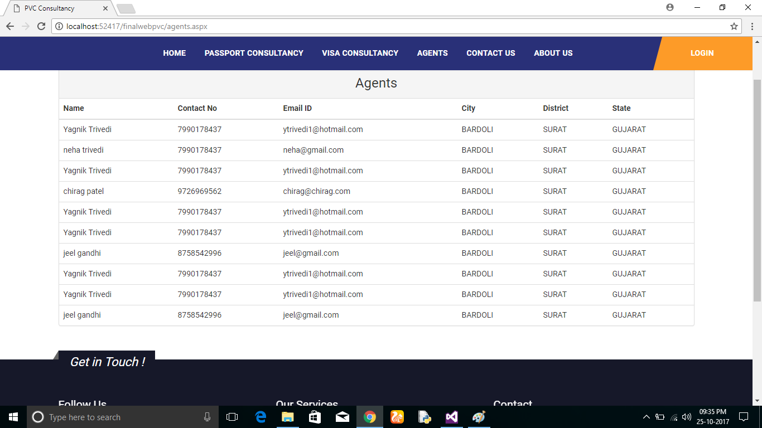

**Visa Consultancy**

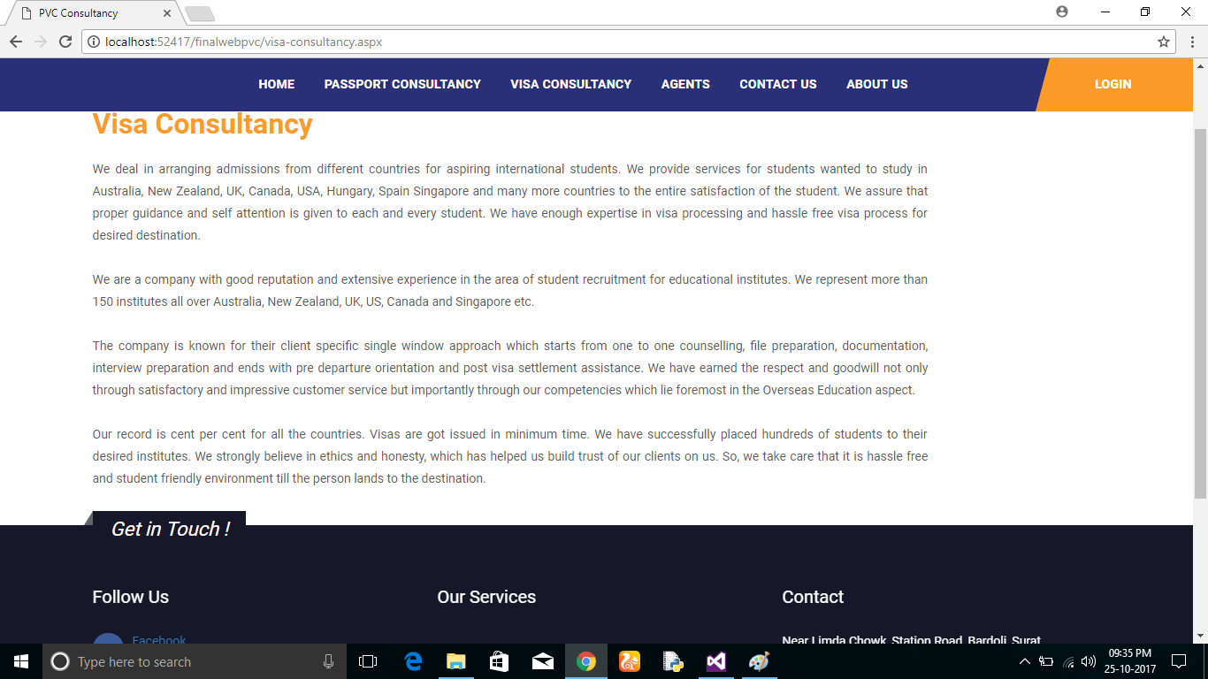

**Passport Consultancy**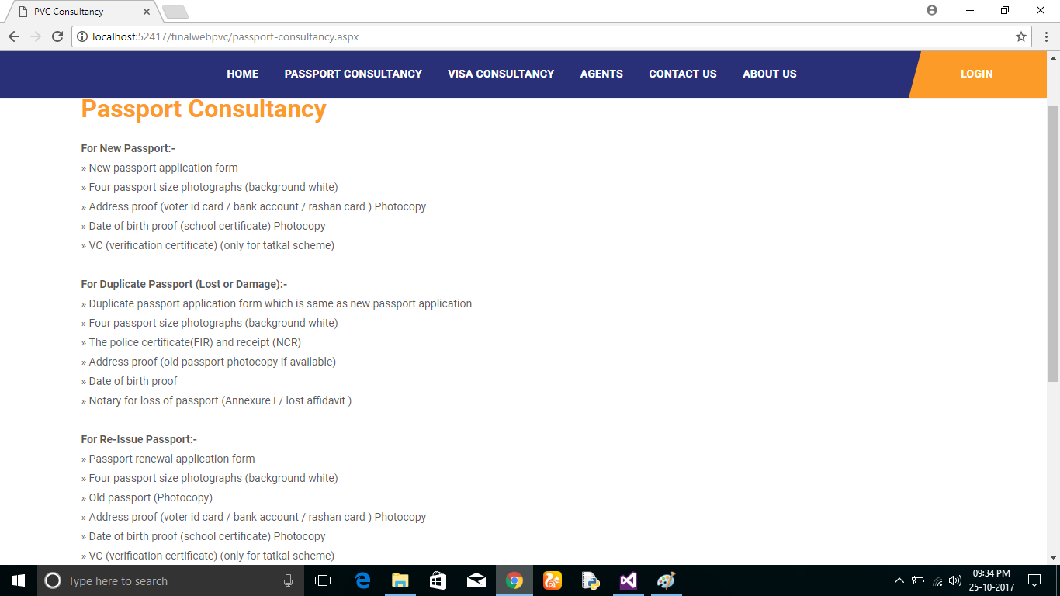

**Footer**

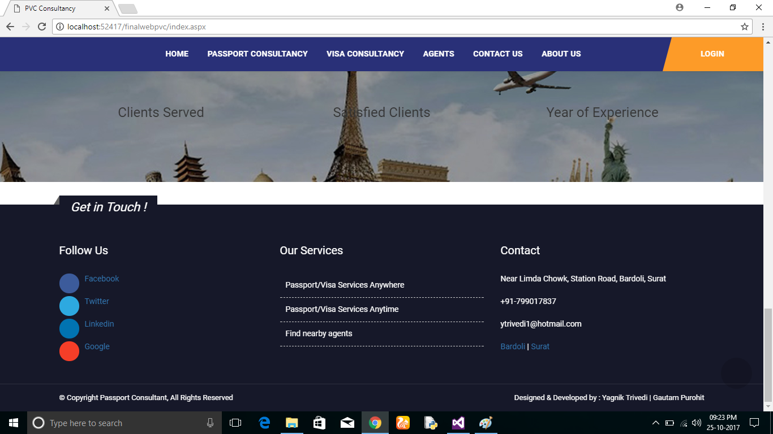

**Index3**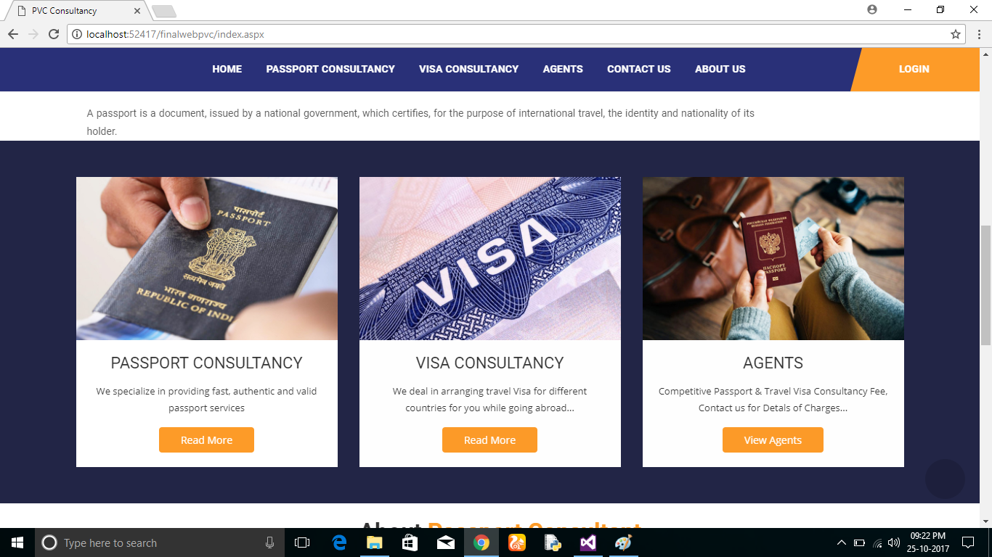

**Index2**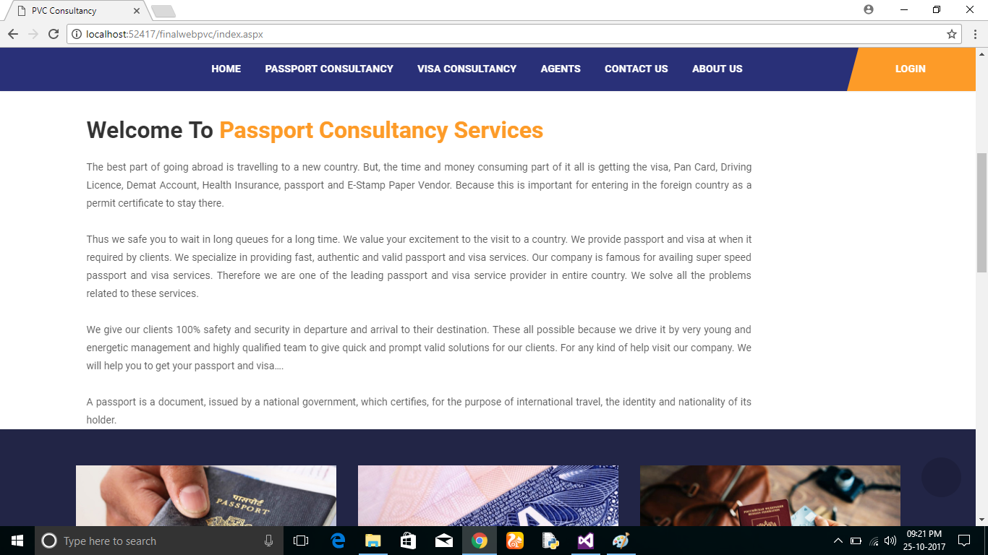

**Index1**



**Validation Screenshots:**

**Customer Personal Details Form**

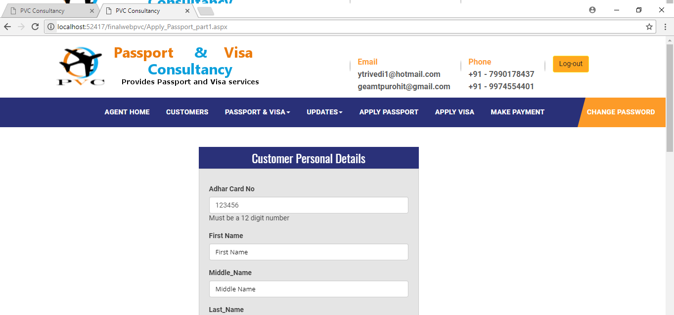

**Customer Personal Details Form**

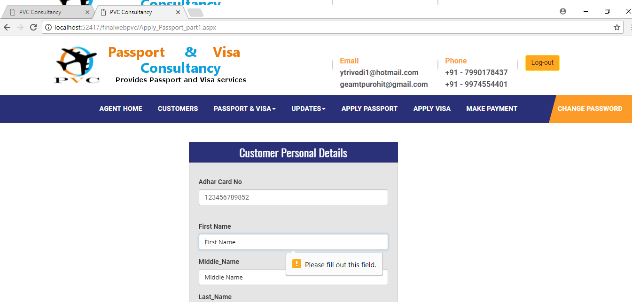

**Customer Personal Details Form**

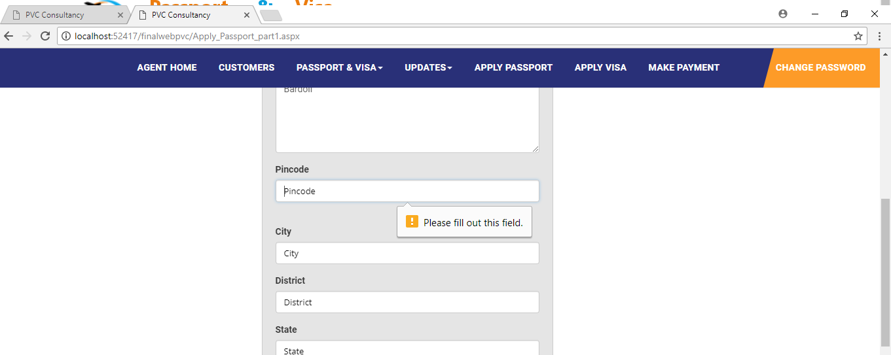

**Customer Personal Details Form**

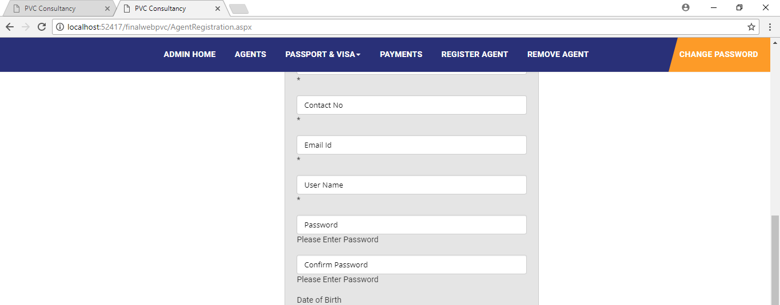

**Visa Details Form**

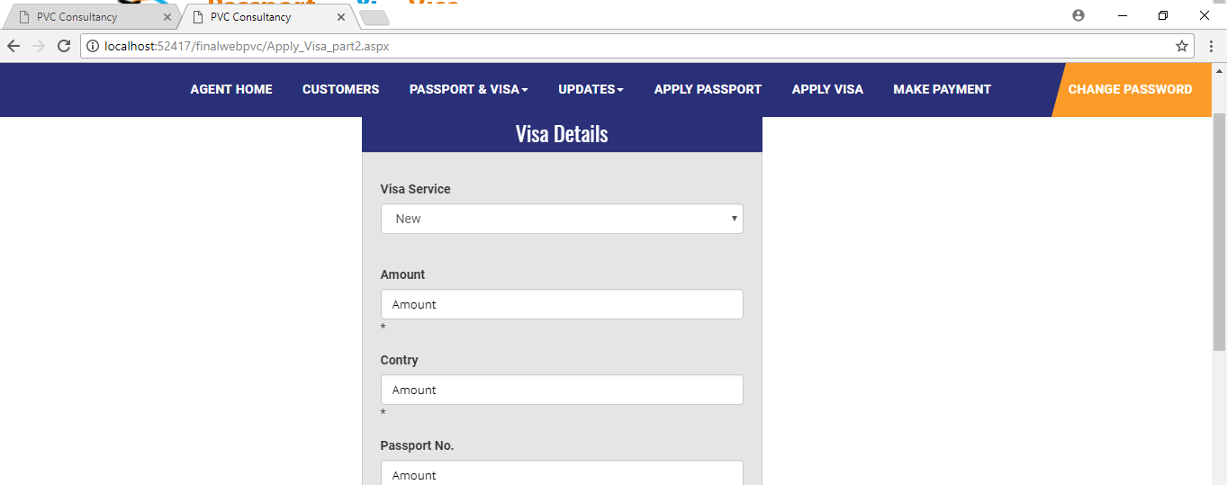

**Payment For Agent Form**

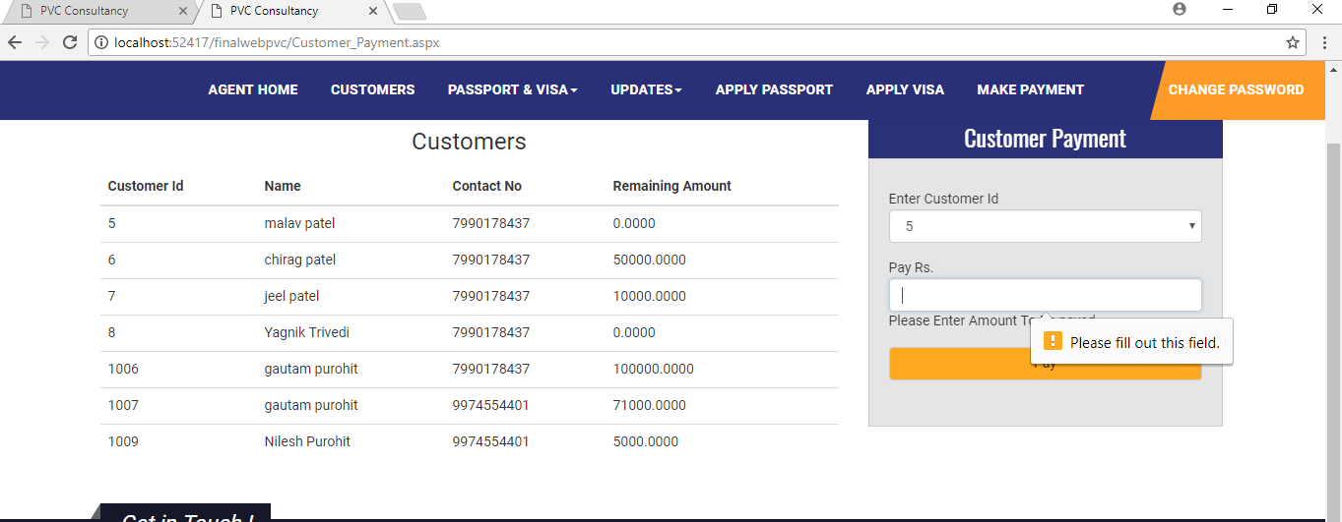

**Change Password Form**

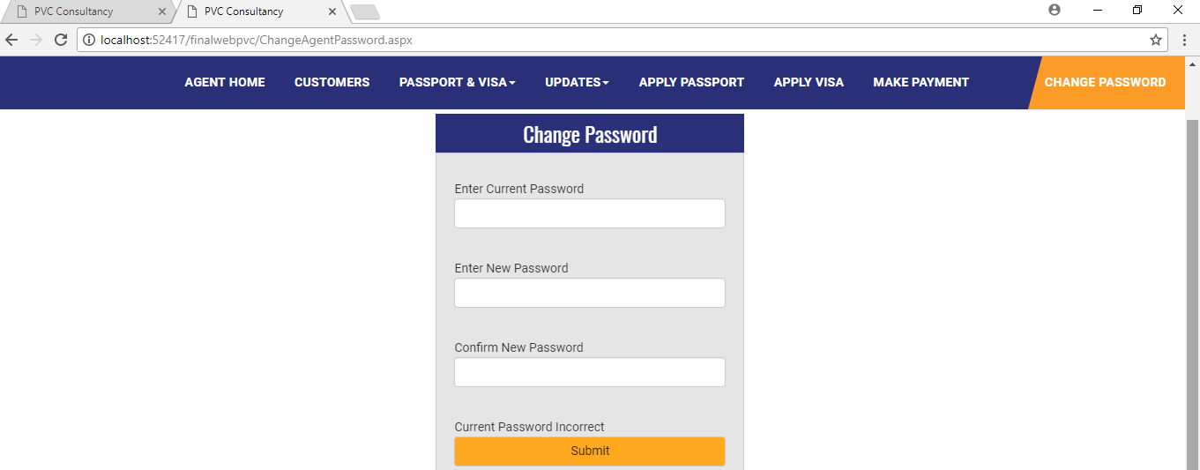

**Login Form**

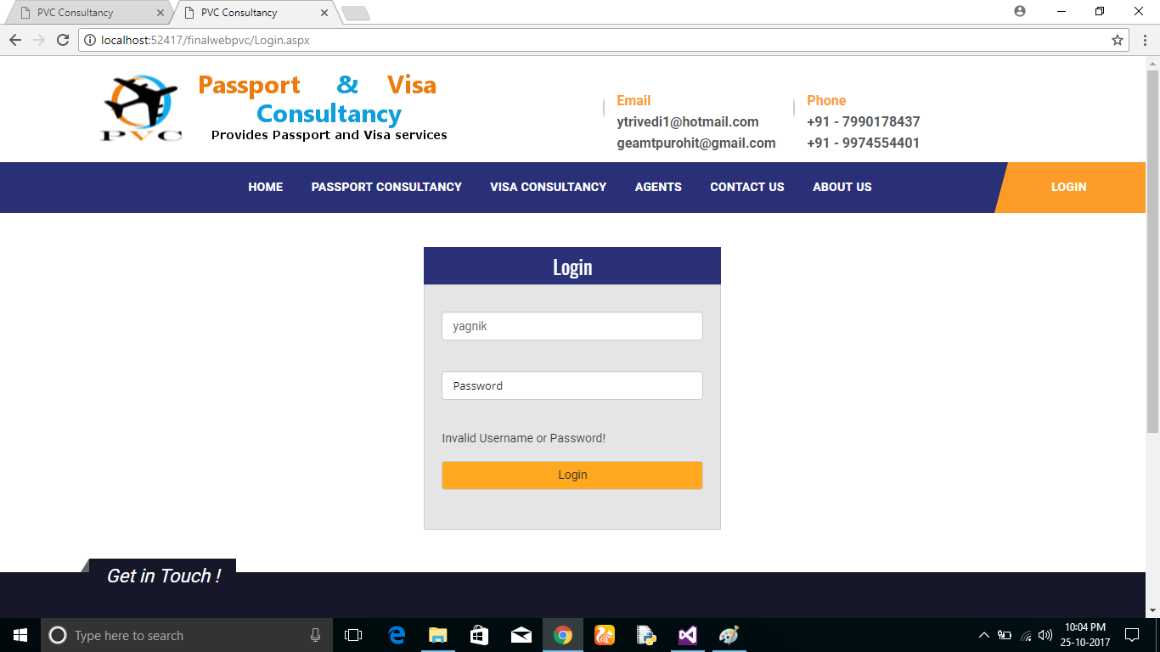

**Change Password Form**

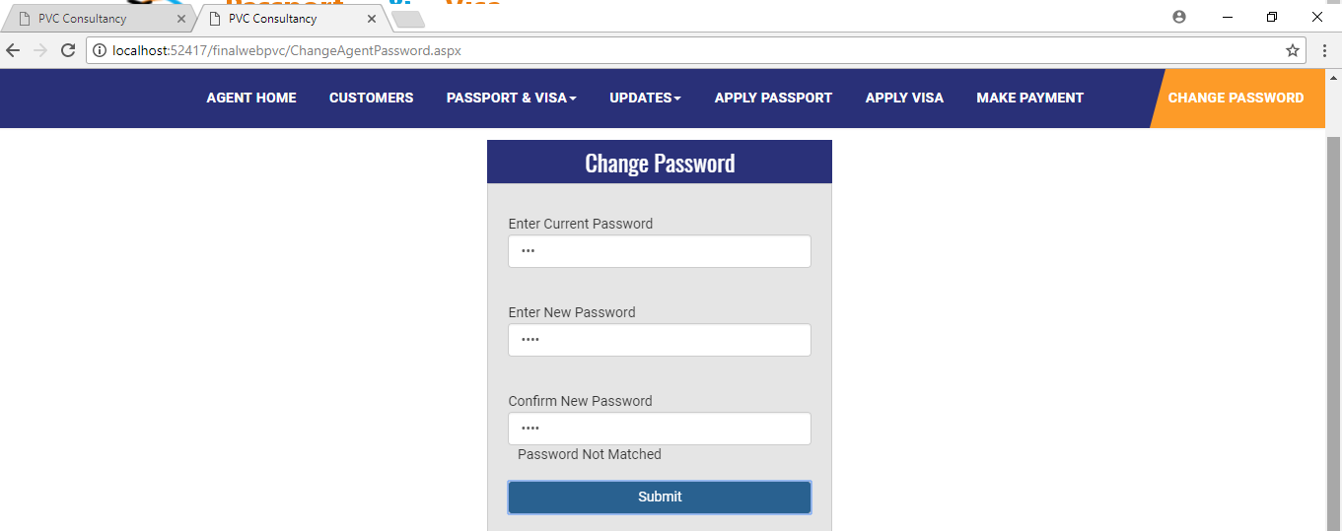

**Payment For Admin Form**

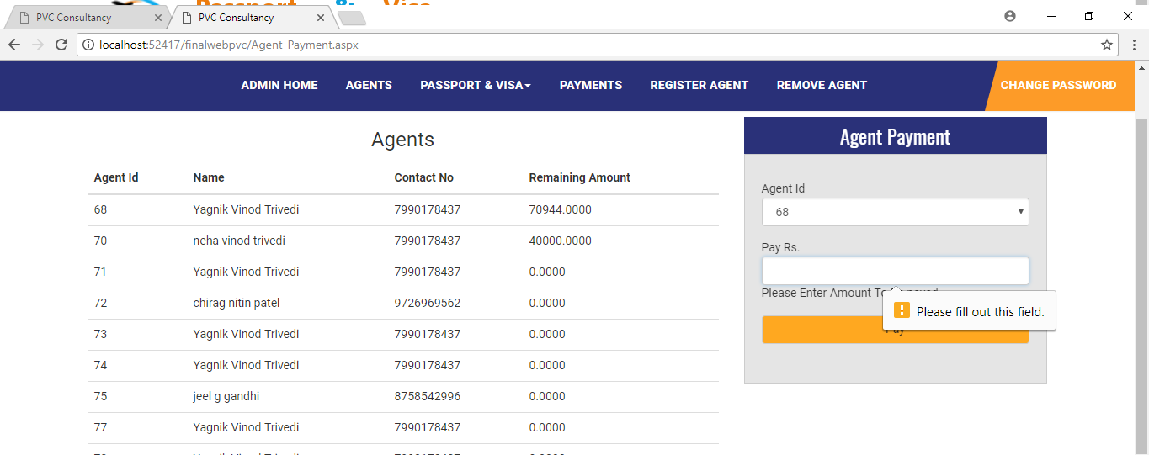

**Technical Details of new features, plug-in tools:**

An API for sending sms is used, which allow you to send text sms of your own to multiple mobile numbers.

**Future Enhancement:**

The inbuilt facility of applying passport and visa can be integrated.

The system can be integrated including to provide facility of booking flights.

The system can include travelling facility, hotel booking.

**Conclusion:**

The system resolves the problem of maintaining the documents.

The system provides the automatic updates of visa and passport services which enable applicants to get about their application process.

The system provides of information for applying passport and visa, and documents to be required.

**Learning Experience during project work:**

Experienced team work.

Project work challenge us to think beyond the boundaries of the classroom, helping us to develop the skills, behaviours, and confidence necessary for success in the 21st century.

We have gained knowledge of UMLet, HTML, CSS, jQuery, C#, JavaScript in detail.

Project learning is a very important part of the curriculum

**References:**

[www.google.com](http://www.google.com)

[www.stackoverflow.com](http://www.stackoverflow.com)

[www.codeproject.com](http://www.codeproject.com)

[www.w3schools.com](http://www.w3schools.com)

[www.github.com](http://www.github.com)

Book: Object Oriented Software Engineering By Yogesh Singh and Ruchika Malhotra

**Bibilography:**

The following books were referred during the analysis and execution phase of the project.

**MICROSOFT .NET WITH C#**

Microsoft .net series

**ASP .NET 2.0 PROFESSIONAL**

Wrox Publisher

**ASP .NET WITH C# 2005**

Apress Publication

**C# COOK BOOK**

O reilly Publication

**PROGRAMMING MICROSOFT ASP .NET 2.0 APPLICATION**

Wrox Professional Guide

**BEGINNING ASP .NET 2.0 E-COMMERCE IN C# 2005**

Novice to Professional.